Summary of the Work of Changyu Wine Culture Museum in 2023

In 2023, the cultural and museum industry is truly recovering. The Changyu Wine Culture Museum seized the opportunity to make great progress in enriching its collection, academic research, cultural and creative product development, social education, and other aspects. While doing a good job in economic income generation, it has achieved good social benefits.

1、 Business situation  
The museum has achieved a cumulative fund recovery of 24.91 million yuan, an increase of 5.14 million yuan or 26% compared to 2021. The incurred expenses amounted to 17.67 million yuan, an increase of 3.96 million yuan from 13.7 million yuan in 2021.

2、 Collection Collection  
The upgraded museum has strengthened the collection of various collections through various means, and has received support from wine enthusiasts and historical and cultural enthusiasts in Changyu from all over the world. Free donations have been made by collectors from Shanghai, Mr. Chen Xiaomin, and local wine enthusiast Mr. Zhang Shirui. Mr. Chen Xiaomin donated historical materials such as advertising flyers, brochures, and delivery notes for early products of Changyu Company. Mr. Zhang Shirui, as a wine enthusiast, donated collections such as Changyu wine from the 1980s and local brand wines from Yantai. Changyu Group Company has mobilized internal resources to support the reserve and updating of museum collections, and has transferred over 60000 new collections to the museum, including 652 for brewing equipment, 17820 for wine labels, 6568 for calligraphy, painting, art, and honors, 7126 for books and archives, and 28110 for video and imaging, greatly enriching the museum's collection resources.

Through the collection of collections, a new image of the museum has been established, showcasing its role in social construction more fully. It has become a platform for sharing wine information resources and maximized its function in serving society.

3、 Academic research and scientific research  
Since its new opening, it has received a large number of Chinese and foreign tourists, industry experts, and peers, playing an important role in leading the development of the wine industry and cultural dissemination. However, it also deeply feels that there is a certain gap in wine technology research. For this reason, this year we have hired experts in brewing, technology, and quality from Changyu Company as academic advisors for the study of wine culture in our museum. We have also hired experts from Yantai Museum as academic advisors for the museum's historical relics and exhibition display. We have set up a professional wine tasting room in the museum in collaboration with the Cabernet Sauvignon blending laboratory and technology center, and have achieved many technical achievements. I have published over 10 papers in domestic and foreign journals such as Foods and Journal of the Science of Food and Agriculture, Food and Fermentation Industry, Grapes and Wine from China and Abroad, Food and Fermentation Industry, and Brewing Technology.  
According to the plan at the beginning of the year, our museum has fully collaborated with the company's technology center to establish a professional wine tasting room and a Cabernet Sauvignon blending laboratory in the museum, forming a research venue for the Changyu Wine Culture Museum. This provides convenience for popularizing wine culture, facilitating exchanges among industry experts and peers in sensory tasting, technical testing, product innovation, and scientific research output.

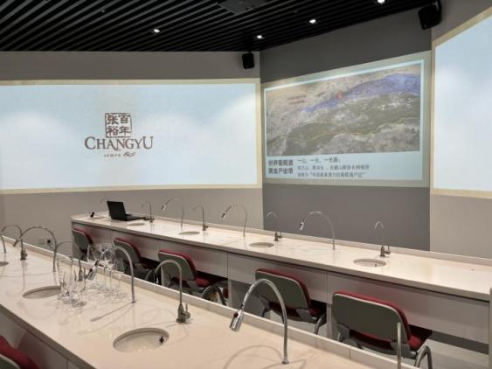

4、 Cultural and creative development  
After the new museum enriches its collection, utilizing its resources and wine elements for cultural and creative product development will be a key task in 2023. This year, through multiple investigations and investigations, we have collaborated with well-known cultural and creative companies in China, such as Panhu Design Laboratory, Oracle Creative, Zhuoshang Creative Officer, Ligao Design, and Putifen, which have first-class research and development teams. We have successively developed various cultural and creative products, including event wine, collection wine, skincare product series, scarves, wine racks, and bottle openers.  
Among them, cultural and creative alcoholic products achieved sales of 2.19 million this year, and the cultural and creative skincare series achieved sales of 330000.

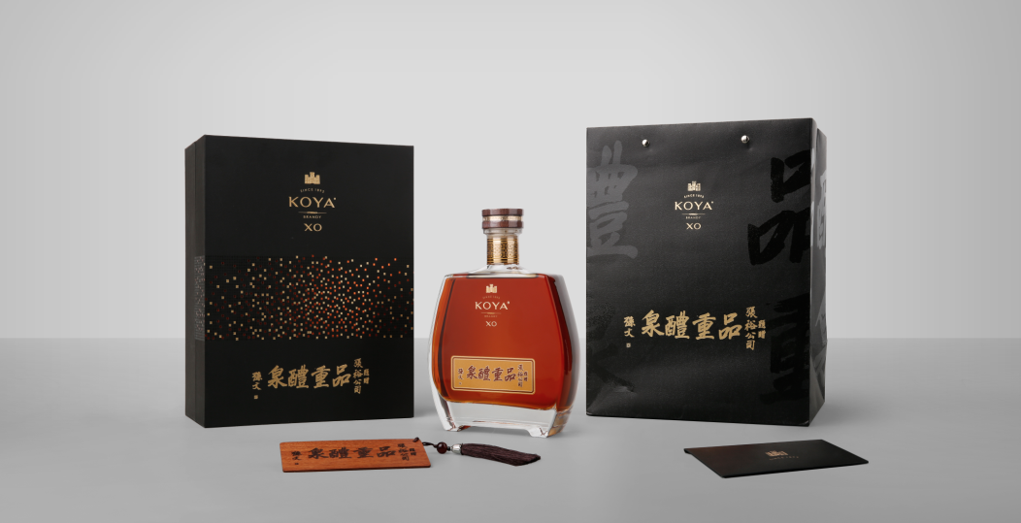

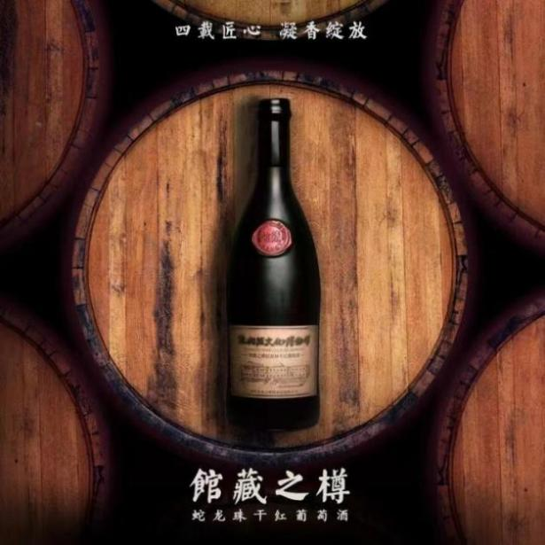

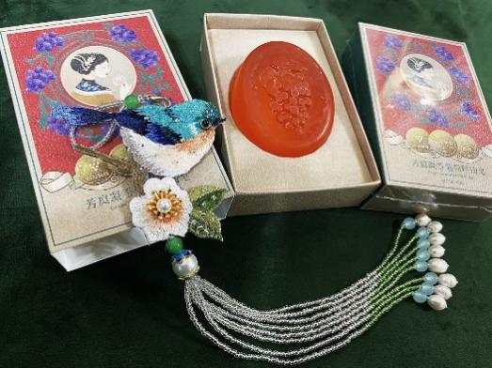

By exploring the connotation of the collection, closely integrating the social service function of the museum with related industries such as cultural creativity and tourism, vigorously developing museum cultural derivative products, enhancing the museum's self generating ability, and achieving sustainable development of the museum.  
5、 Propaganda and education  
1. Utilize the advantages of museums to continuously promote mid to high end tourism, increase investment in the foreign guest market, and ensure the rapid recovery of the foreign guest market. We have launched a boutique tourism route with a large local agency in Malaysia, "Tasting Grape and Wine, Seeking Delicious Yantai", and introduced a Malaysian team of 3254 people. Participate in the 3rd China International Cultural Tourism Expo, promote and publicize museum tourism resources.

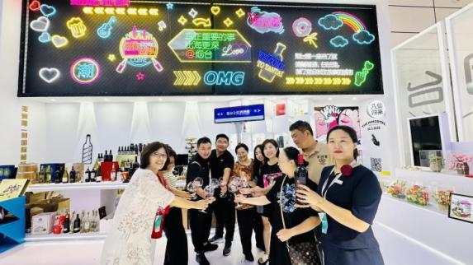

2. The museum's gold medal lecturer walked into Yantai Cultural Tourism Vocational College to explain popular science knowledge such as wine culture and serving etiquette to 100 college students.

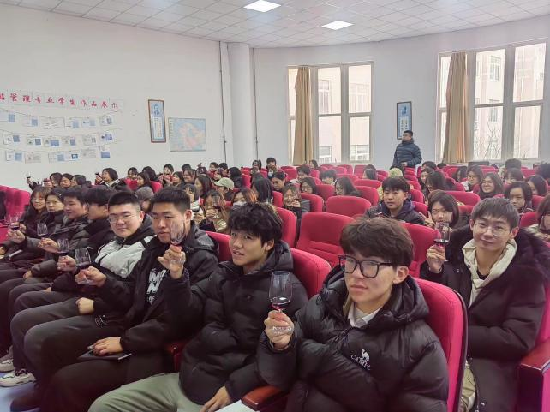

3. On May 4, 2023, our museum held the "Drunk Poet Immortal" Poetry Competition in Changyu. Participants from various counties and cities in Weifang, Qingdao, and Yantai contributed more than 100 beautiful poems. Hong Yuyan, the director of the Changyu Wine Culture Museum, delivered a welcome speech on behalf of the organizers. Wang Donglin, President of Yantai Poetry Society, and Guo Shunmin, President of Weifang Poetry Society, attended the ceremony and delivered speeches. This event aims to help more people understand wine culture and the "International Grape and Wine City" of Yantai.

6、 Human resources support  
This year, in order to cooperate with the new museum and carry out school enterprise cooperation and co construction with various professional colleges, labor training will be moved to universities to timely discover and supplement professional talents that meet the needs of museum development; During the off-season, special training will be conducted on explanation and wine telling, with a focus on dynamic and storytelling in explanation and specialization in wine telling; During the peak season, a service-oriented marketing star and innovation star evaluation activity is launched every week, which is shared during morning meetings and motivates employees.

7、 Obtain honors  
Through the efforts of all staff in the museum, the following honors were awarded in 2023:  
1. Awarded the title of Top 10 Female Workers' Exemplary Role Model for Merit and Career by the Yantai Municipal Federation of Trade Unions;  
2. The Changyu Wine Culture Museum was awarded the first museum tour boutique project in Yantai City;  
3. In the "Breakthrough Zhifu Achievements with Me" themed speech competition, Cui Xueyan won the second prize and the third prize in the "National Revitalization with Me" speech competition to welcome the 20th National Congress of the Communist Party of China; Fu Zhenyuan won the third prize in the "Chinese Dream, New Era, and New Mission" Youth Employee Propaganda Competition organized by the State owned Assets Supervision and Administration Commission for Municipal Enterprises;  
4. In the 2023 Yantai City Tour Guide Vocational Skills Competition, Mou Tiantian won the third prize.

Changyu Wine Culture Museum

January 8, 2024